Documentation of steps:
- Imported raw CSV
- Downloaded the data on Kaggle, imported it into Excel.
- Created the “Seattle Master List”
- Added a new Seattle Master Sheet and copied the entire table from RawData.
- Applied a filter to city (column E) → selected only Seattle, Bellevue, Redmond.
- Checked for missing funding
- Inserted a Bar Chart:
  - Created a new table
  - Formula used: =COUNTIF(F$2:F$49379, "*no_value*")
  - Selected the table and inserted Bar Graph
  - Titled the chart “Data Gaps: Missing Funding Info.”
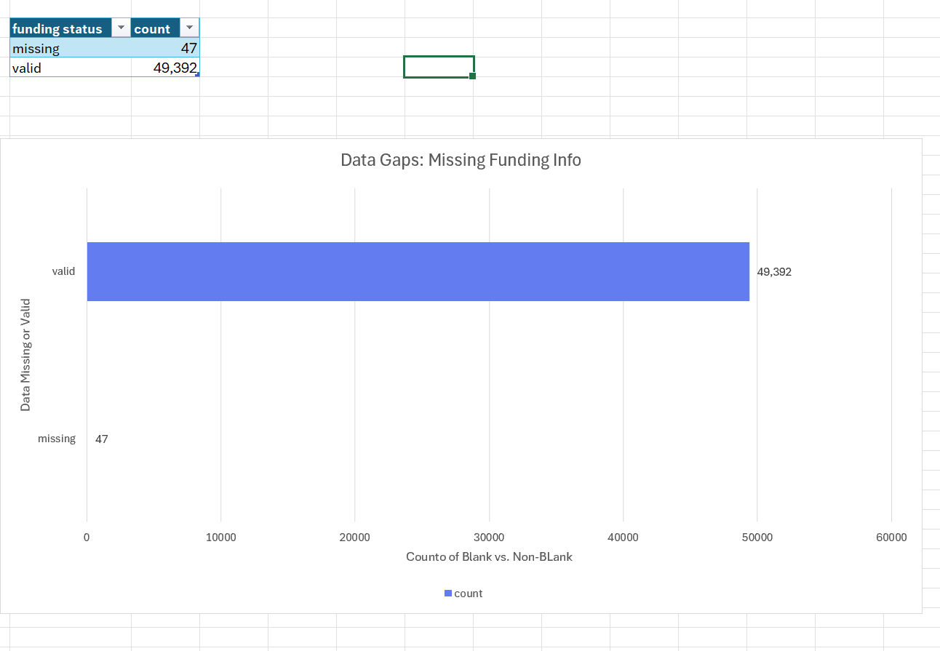

- Cleaned funding data
- Filtered all columns for blanks or zeros → deleted those rows
- Formatted the column as Currency with 0 decimal places
- Also had to format the funding_total_data to follow proper numbering/currency conventions by removing all commas and then re-formatting to be in “1,234” format
- Noted the final row count after cleaning.

- Engineered the Business Model column
- Inserted a new column Business Model (column I)
- In I2 entered the VLOOKUP formula:
  - =VLOOKUP(E24833,'master key'!C$2:D$200,2,FALSE)
- Dragged down to fill the column; verified a random sample of labels.
- Built the Funding & Deal Count PivotTable & Visualizing
- Inserted new Pivot Table
- Filtered data to only show data from 2005-2015 to compare with past time periods.
- In seattle master sheet had to create new column to count how many deals each company had. formula:
  - =SUM(W78:AQ78)
- Sum of funding_total_usd (renamed “Total Funding”) and Count of name
- With the PivotTable selected, Inserted → Pie Chart → set chart title “Funding Share: B2B vs B2C”.
- Added data labels showing percentages.
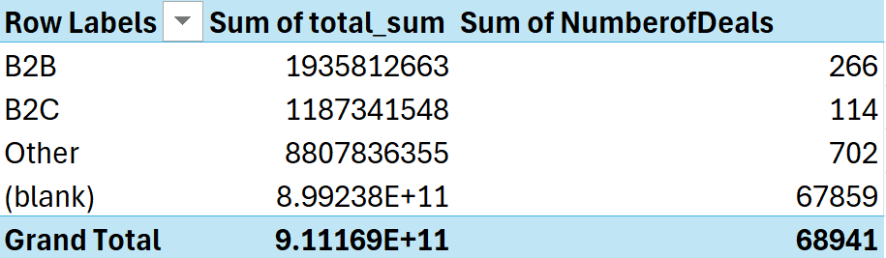
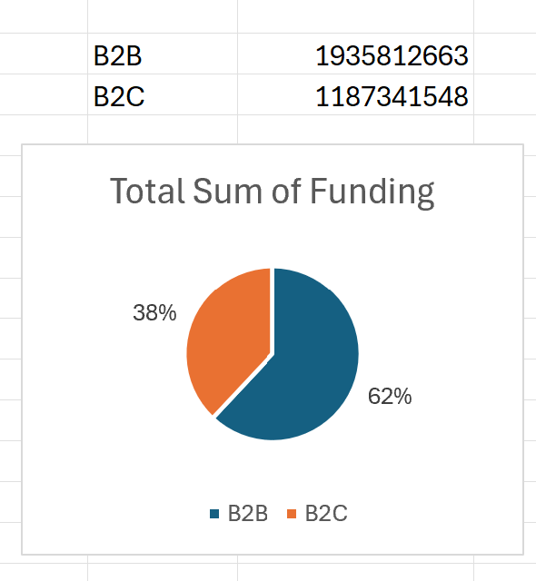
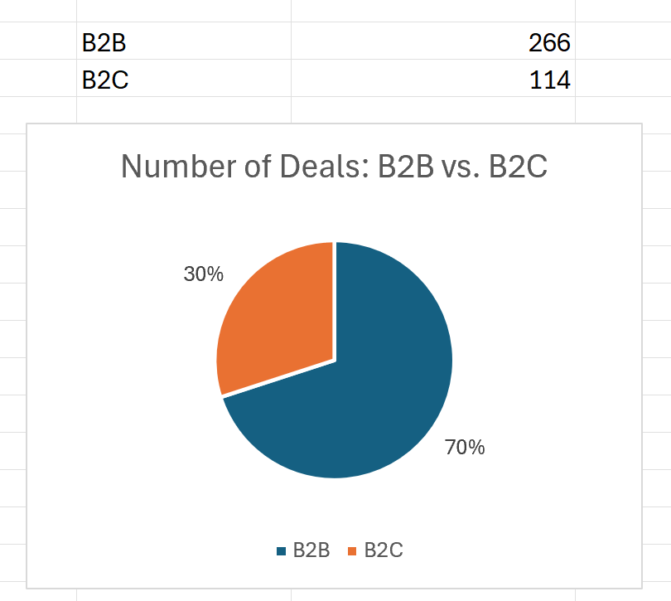

- Created Success rate PivotTable & chart
- Created a new PivotTable on Pivot_Status:
  - Rows: Business Model, Columns: status, Values: Count of name.
  - Inserted a Clustered Bar Chart, titled “Survival Rates by Business Model”.
- **Screenshots on next page:

Sample of data in table (it’s too long to show here):
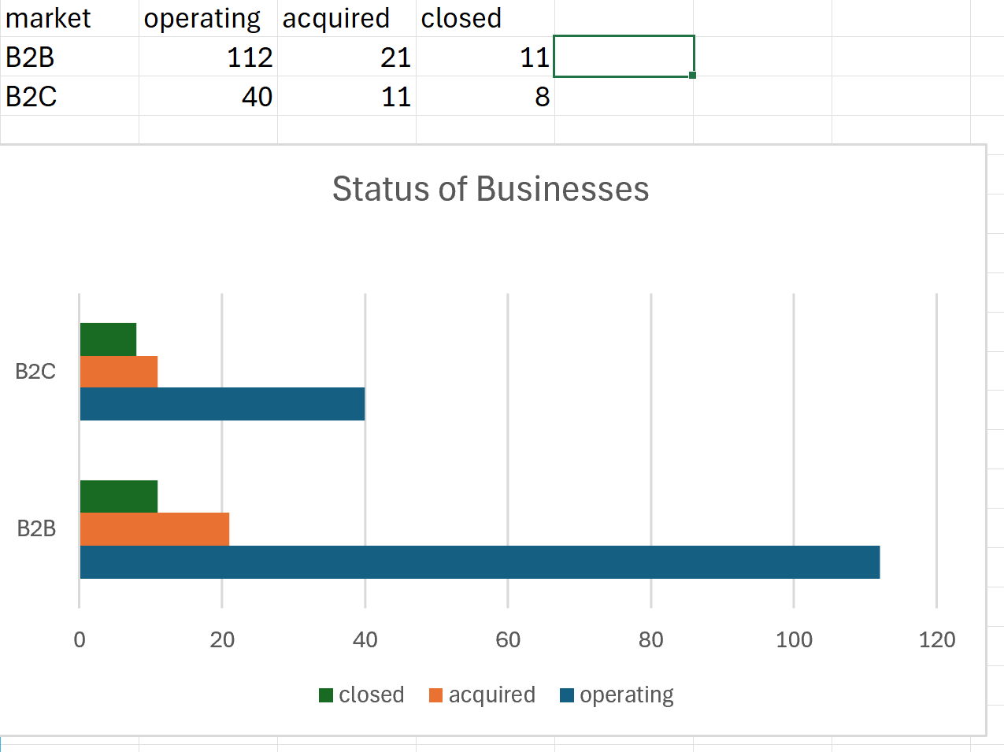
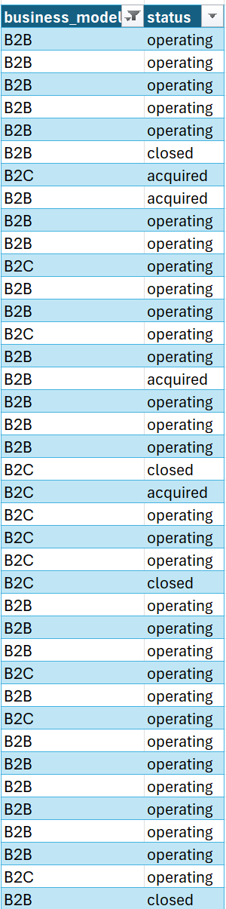 **Had to filter data and create separate table to be able to create chart ↑

- Highlighted top 10 funded companies
- returned to seattle master list → conditional formatting → New Rule → “top 10 items” → formatted with green fil
- Because it is filtered, it was doing top 10 overall. To get top 10 only B2B or B2C, we had to change it to top 50 so we had 10 values that were highest..
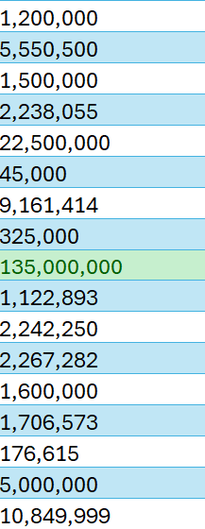
- **Example of what it looks like:

- Executive Summary & Reflection
- typed up executive summary
- typed up reflection answers

Executive Summary

Task 11: The Analyst's Verdict In a new sheet called "Executive Summary", write a 3-4 sentence conclusion.
- Prompt: Based on your charts, was the Senior Partner right (is Seattle shifting to Consumer Apps?) Or was Sarah right (is Seattle a B2B fortress)?

Based on our charts, Sarah was right. According to the number of deals B2B has made over B2C, B2B has a much vaster and wider market of businessed. Although B2C has made more money, if we target the right B2B businesses, we will reach not only the quantity of businesses, but also the quality (around of money) of businesses.

- Recommendation: Should Cascadia Ventures invest in the next "TikTok for Cats" or the next "Cloud Database for Banks"?
Cascadia Ventures should invest in the next “Cloud Database for Banks” as it is a B2B company. Due to our data and research, we have come up with the conclusion that B2B is way more profitable than B2C businesses, so “Cloud Database for Banks” would be better than “TikTok for Cats”

Task 12: Reflection In the same sheet, answer these four questions:
- Which Excel function was the most useful for cleaning this messy data?
The VLOOKUP Excel function was the most useful because it helped use organize the data by labelling it “B2B” or “B2C” or “Other”
- Did the result surprise you, or did it match your expectations of Seattle Tech?
The result was not surprising as Seattle has always been a big tech hub for companies such as Microsoft, Google and Apple. I mean, Bill Gates grew up here.
- What was the most frustrating part of "Feature Engineering" (tagging B2B/B2C)?
The most frustrating part of “Feature Engineering” was to fix any bugs and adjust the formulas we were applying to our worksheet.
- If you had access to any data in the world, what one extra column would you have wanted?
If we had access to any data in the world, we would have added a column that captures who the primary users of the company’s product/service were. This would help us further segregate the B2B startups to see if they’re large firms or mid-size companies. It would also help create a correlation between market size and funding received.

